Do you have all these Questions on your mind?

* When is my next class?
* Which assignments I have to complete for today?
* When is my next group meeting?
* What all is going on in campus?
* How much marks I got in my class?

We have a solution for you!!

Phase 1 (Time Table Auto- Generation)

* Automatic time table generation - Administrator can design time table
* Non-Admin user (Student, Teacher etc.) can view the auto-generated Time table

Phase – 2 (Notification)

* Notice Board with one way communication i.e. administration office notifications to faculty and students, club notifications, faculty notifications to the class.
* Information about the assignments, project deadlines etc.

Phase – 3 (Social Media)

* Social media platform for an organization where formal and informal communication can take place.
* Facility to create the Study groups, Clubs and Class groups etc.

Phase – 4 (Feedback)

* Feedbacks regarding the events, teachers etc.

College Benefits:

* Smooth flow of information
* Teacher schedules
* Class Feedbacks
* Paper savings
* Easy to manage/update class schedules
* Notifications to students, faculty,
* Meeting notifications to students, faculty

Target customers:

1. Colleges
2. Universities

After phase – 4 we can target:

1. Private companies

Designs

**Mobile Interfaces:**

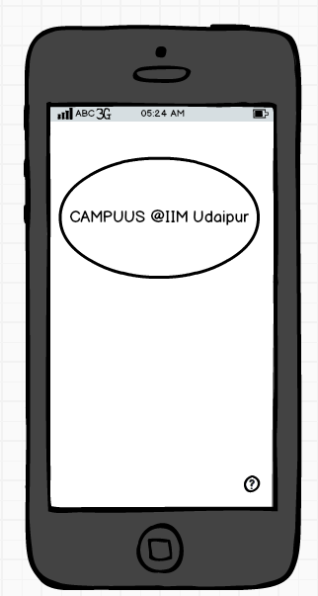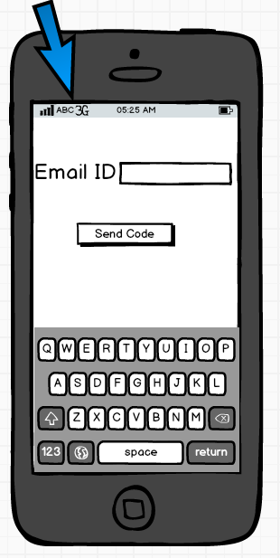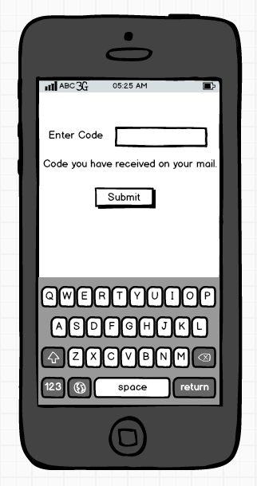

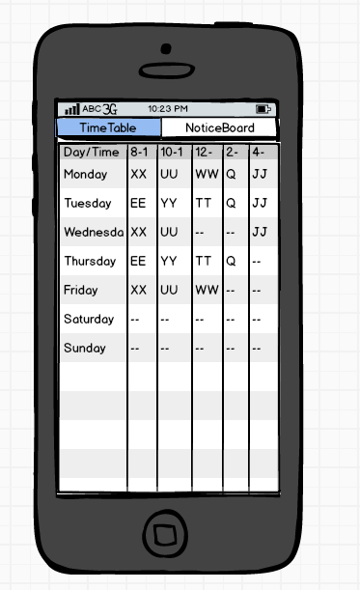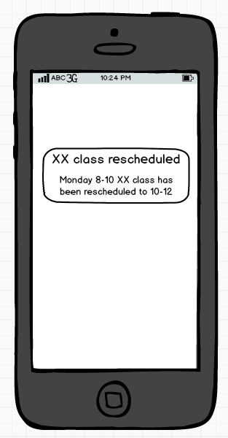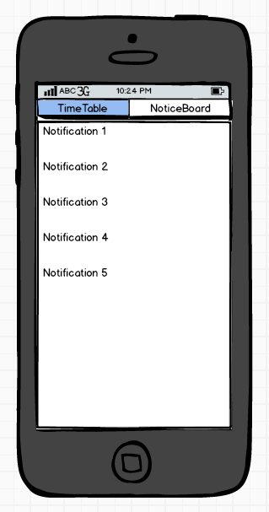

**Admin Interface/ Computer Interface:**

